Vladimir Lenin
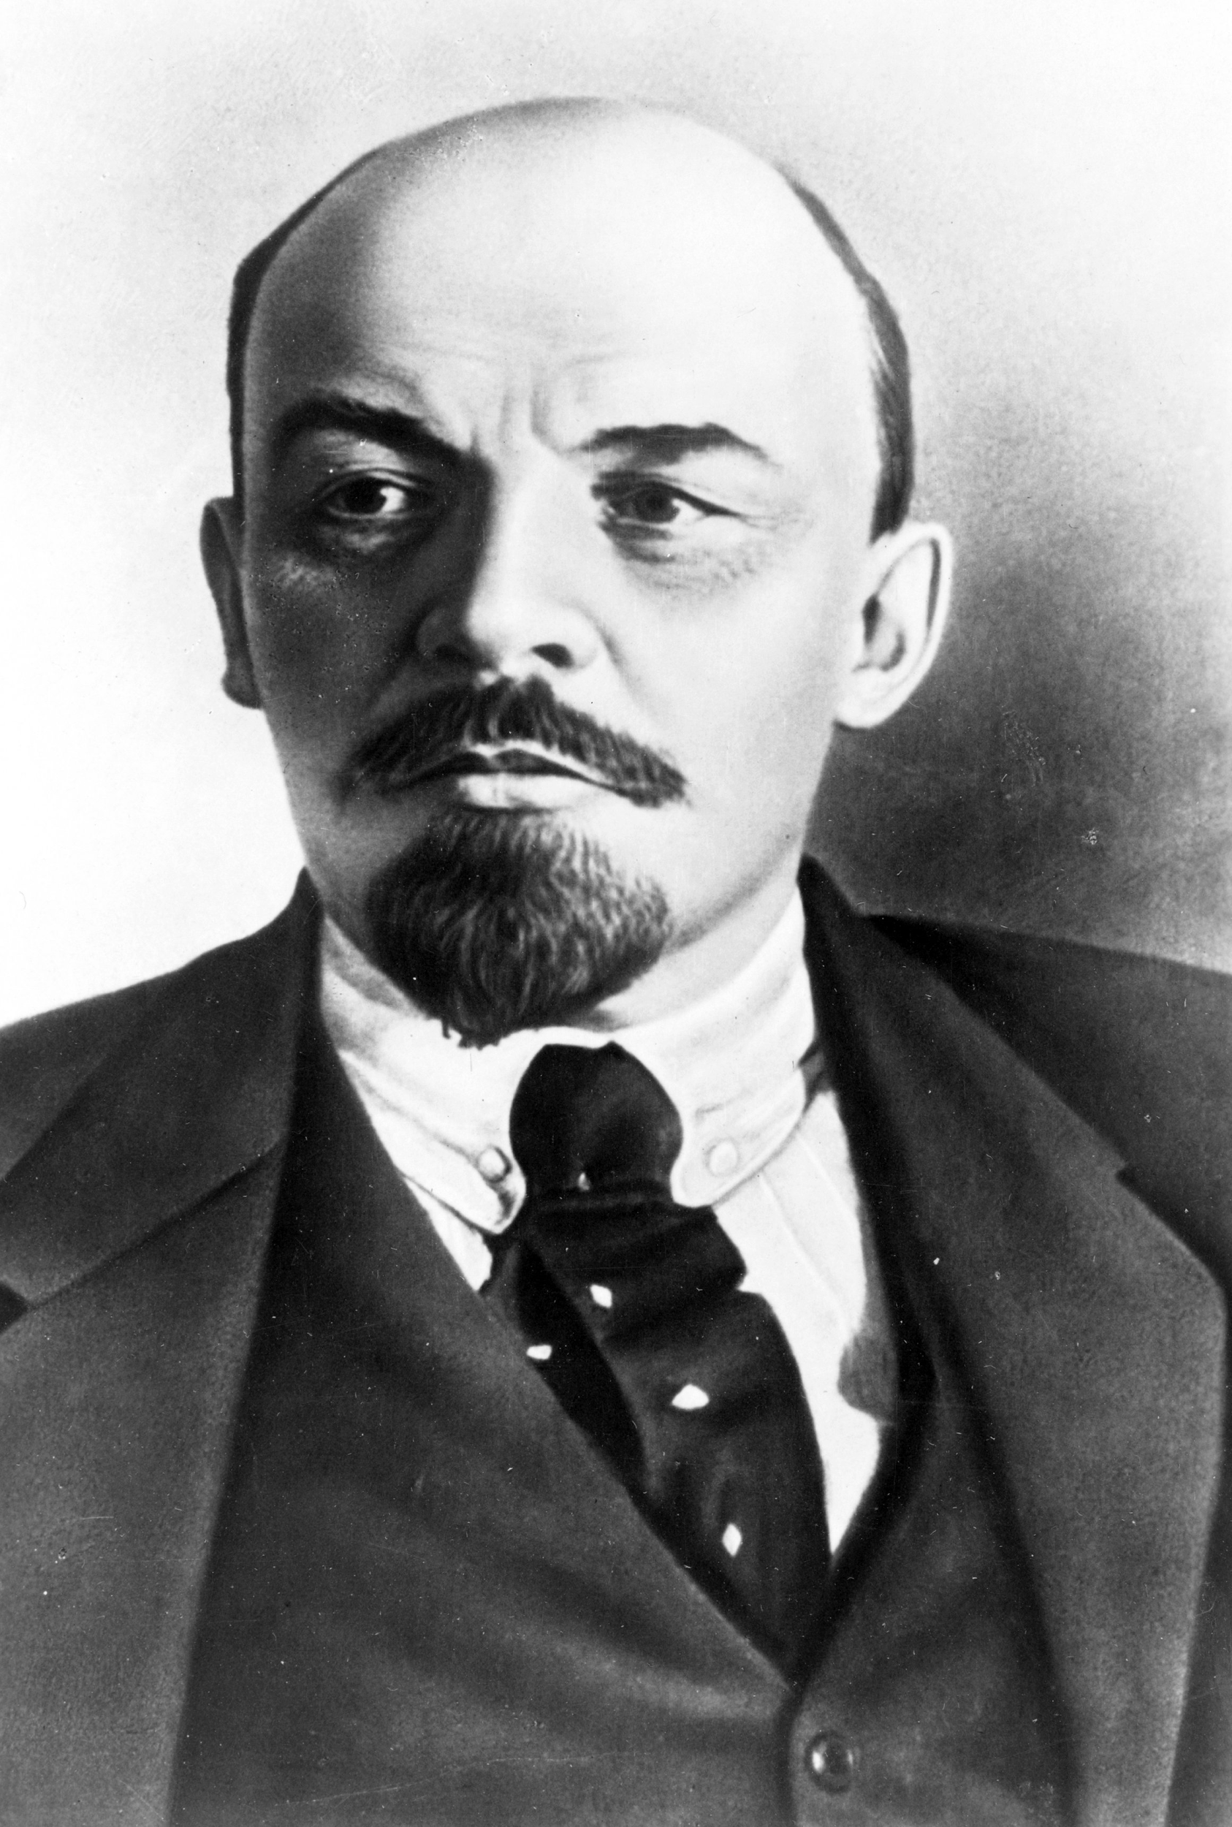

Introduction:
Vladimir Lenin was born on April 22 1870 in Simbirsk Russia which was later renamed Ulyanovsk in his honor. In 1901 he adopted the last name Lenin while doing underground party work. Lenin went on to finish first in his high school class, showing a particular gift for Latin and Greek. Vladimir Lenin was a founder of the Russian Communist Party in 1917 and later took over as the newly formed Union of Soviet Socialist Republics (USSR). Leader of the Bolshevik Revolution and first head of soviet union. Lenin has been been regarded as the greatest revolutionary leader and thinker. After several incidents in Lenin’s family he became the man in the family. All of Lenin’s siblings would take part to some degree in revolutionary activities.
Young Revolution:
The year of his brother’s execution, Lenin enrolled at Kazan University to study law. During his first term he was expelled for taking part in student demonstration. Lenin took up residence with his sister Anna. Eventually Lenin received his law degree finishing his school work in 1892. He moved to the city of Samara. Lenin focused more of his energy on revolutionary politics. He left Samara in mid 1890’s for a new life in St. Petersburg, the Russian capital at the time. There Lenin connected with other like-minded Marxists, and began to take an active role in their activities. In December 1895, Lenin and other Marxists leaders got arrested. Lenin was exiled to Siberia for 3 years. His fiancee and future wife joined him.
Russian Leader:
In 1917, Lenin quickly returned home, and perhaps sensing his own path to power. Lenin called for a Soviet government, on that would be ruled directly by soldiers, peasants and workers. In late 1917 Lenin led what was soon to be known as October Revolution. Three years of civil war followed. Determined to win at any cost, Lenin showed himself to be ruthless in his push to secure power. He launched what came to be known as the Red Terror, a vicious campaign Lenin used to eliminate the opposition within the civilian population. In August 1918 Lenin narrowly escaped an assassination attempt, when he was severely wounded with a pair of bullets from a political opponent. Lenin came out victorious. But the kind of country he hoped to lead never ended up happening.
Later Years:
Lenin suffered a stroke in May 1922, and then a second one in December of that year. Lenin turned his thoughts to how the newly formed USSR would be governed after he was gone. On March 10, 1923, Lenin’s health was dealt another severe blow when he suffered an additional stroke, this one taking away his ability to speak and concluding his political work. Nearly 10 months later, on January 21, 1924 he passed away in the village now known as Gorki Leninskiye. His corpse was embalmed and placed in a mausoleum on Moscow’s Red Square.

Works Cited

"Vladimir Lenin Biography." Bio.com. A&E Networks Television, n.d. Web. 16 Oct. 2015.

BBC News. BBC, n.d. Web. 21 Oct. 2015.

Prominent Russians: Vladimir Lenin." Vladimir Lenin – Russiapedia Leaders Prominent Russians. N.p., n.d. Web. 22 Oct. 2015.

